**MAT 3312 Homework 5 Spring 21 (Hand written and Computing Assignment)**

**Name:________________ Date:________________**

**Due by 12:40pm April 19st You will only have one attempt to upload. This assignment requires SAS.**

**Answer Questions 1-4 by hand**

Needles are one of the most commonly shared drug supplies among users. Is there an association between sharing needs to inject drugs and contracting HIV? A survey was conducted on 100 users. **Use the table below to answer questions 1-4.**

|  |  |  |
| --- | --- | --- |
|  | Positive for HIV | Negative for HIV |
| Share needles | 32 | 18 |
| Do not share needles | 10 | 40 |

**Question 1.** Calculate the expected contingency table.

**Question 2.** Calculate the chi-square test statistic.

**Question 3.** What is the p-value based on the chi-square test?

**Question 4.** What is the conclusion from the chi-square test?

**Use SAS to answer the questions below**

The data set in the table below is based on 214 children with acute otitis media (OME) who participated in a randomized clinical trial. Each child had OME at the beginning of the study in either one or both ears and was randomly assigned to receive a 14-day course of one of two antibiotics either celfaclor (CEF) or amoxicillian (AMO)

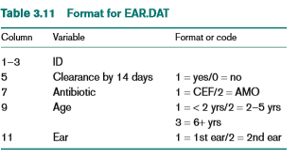

**Import the ear dataset in the SAS to answer the questions below.**

**Question 5.** What is the distribution regarding age in the dataset? Please provide a contingency table (with count and percent) to show the distribution of the variable. Paste results from SAS here.

**Test whether there is an association between medication received and clearance of infection by 14 days? Use the information to answer questions 6-8.**

**Question 6.** Perform a chi-square test and provide the contingency table from the test. Paste results from SAS here.

**Question 7.** What is the chi-square test statistics?

**Question 8.** What is the p-value?

**Question 9.** What is the conclusion?